19th of April 2022

The Head of Denpasar Institute

Dear Sir/Madam,

I noticed that the position as a Freelance Translator is available in Denpasar Institute Bali, since then, I would like to apply the position as a Freelance Translator in Denpasar Institute Bali.

I work as an English Lecturer in Bali Dwipa University as my teaching experience for more than five years. Besides, I also work as an interpreter for the police office of Kuta Utara which gives me a lot of experiences in doing the interpreting job. I was graduated from Master Degree of Translation Studies, so I am confidence that I have the capability to work as a Freelance Translator in Denpasar Institute Bali.

Please find details of my profile that provides information of my qualifications and work experiences. I look forward to hearing from you soon and to being given the opportunity to be able to work in Denpasar Institute Bali.

Yours Sincerely

**I Made Juliarta, S.S., M.Hum.**

**Profile**

Name : **I Made Juliarta, S.S., M.Hum.**

Nationality : Indonesia (Balinese)

Home address : JalanKertha Lestari Blok II no 20 Denpasar Selatan Bali

Phone Number **: 083115041037**

Education :- SD 10 Pedungan

* SMPN 6 Denpasar
* SMAN 5 Denpasar
* English Study, Udayana University (S1)
* Master Degree of Translation, University of Udayana (S2)

Job experience : -English Teacher for Learn Bahasa Course, 2012

- English Teacher for Just Say English, 2013.

* English Teacher forHidden Hills Villa, 2014.
* English Lecturer for Nursig Department, Polytechnic of Health ; 2014-now

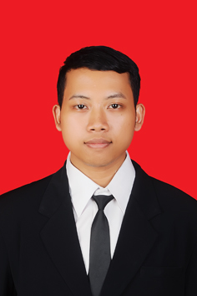

**I Made Juliarta, S.S., M.Hum.**